5.1

**1.Using a ternary operator, write an if/else statement that will return true or false if the variable x is less than or equal to 7.**

public class Main {

public static void main(String[] args) {

int x = 5;

boolean result = (x <= 7) ? true : false;

System.out.println("Is x less than or equal to 7? " + result);

}

}

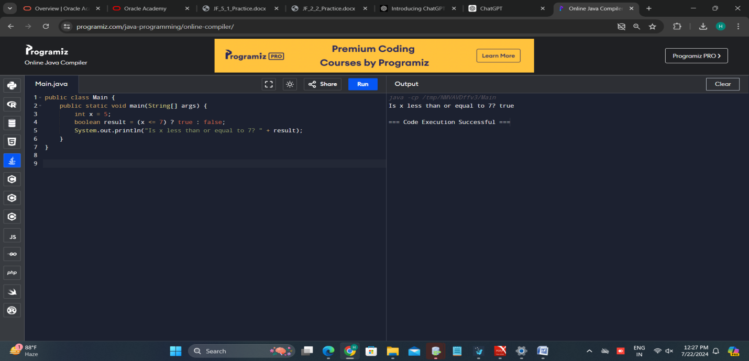

2. **Write a program that prompts the user to enter two floating point (double) numbers and an operator ( *, +, /, %, -). Print the results of the given operation. For reading the command line, use the Scanner class. Write the program first using switch logic, then re-write the program using if/else logic.**

**Switch case:**

**import java.util.Scanner;**

**public class CalculatorSwitch {**

**public static void main(String[] args) {**

**Scanner scanner = new Scanner(System.in);**

**System.out.print("Enter the first number: ");**

**double num1 = scanner.nextDouble();**

**System.out.print("Enter the second number: ");**

**double num2 = scanner.nextDouble();**

**System.out.print("Enter an operator (*, +, /, %, -): ");**

**char operator = scanner.next().charAt(0);**

**double result;**

**switch (operator) {**

**case '*':**

**result = num1 * num2;**

**System.out.println("Result: " + result);**

**break;**

**case '+':**

**result = num1 + num2;**

**System.out.println("Result: " + result);**

**break;**

**case '/':**

**if (num2 != 0) {**

**result = num1 / num2;**

**System.out.println("Result: " + result);**

**} else {**

**System.out.println("Error: Division by zero");**

**}**

**break;**

**case '%':**

**if (num2 != 0) {**

**result = num1 % num2;**

**System.out.println("Result: " + result);**

**} else {**

**System.out.println("Error: Division by zero");**

**}**

**break;**

**case '-':**

**result = num1 - num2;**

**System.out.println("Result: " + result);**

**break;**

**default:**

**System.out.println("Error: Invalid operator");**

**break;**

**}**

**scanner.close();**

**}**

**}**

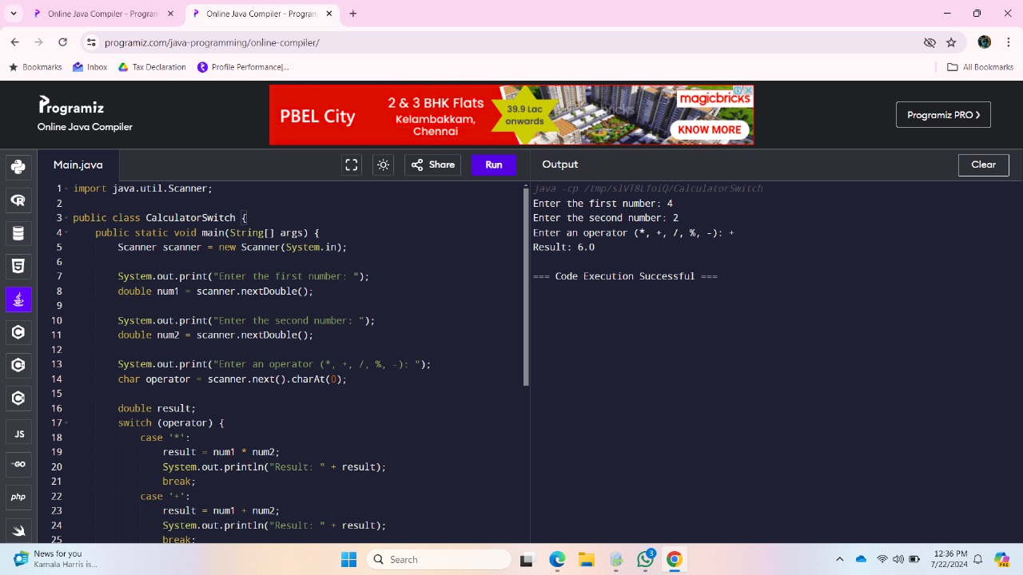

***If-Else:***

**import java.util.Scanner;**

**public class CalculatorIfElse {**

**public static void main(String[] args) {**

**Scanner scanner = new Scanner(System.in);**

**System.out.print("Enter the first number: ");**

**double num1 = scanner.nextDouble();**

**System.out.print("Enter the second number: ");**

**double num2 = scanner.nextDouble();**

**System.out.print("Enter an operator (*, +, /, %, -): ");**

**char operator = scanner.next().charAt(0);**

**double result;**

**if (operator == '*') {**

**result = num1 * num2;**

**System.out.println("Result: " + result);**

**} else if (operator == '+') {**

**result = num1 + num2;**

**System.out.println("Result: " + result);**

**} else if (operator == '/') {**

**if (num2 != 0) {**

**result = num1 / num2;**

**System.out.println("Result: " + result);**

**} else {**

**System.out.println("Error: Division by zero");**

**}**

**} else if (operator == '%') {**

**if (num2 != 0) {**

**result = num1 % num2;**

**System.out.println("Result: " + result);**

**} else {**

**System.out.println("Error: Division by zero");**

**}**

**} else if (operator == '-') {**

**result = num1 - num2;**

**System.out.println("Result: " + result);**

**} else {**

**System.out.println("Error: Invalid operator");**

**}**

**scanner.close();**

**}**

**}**

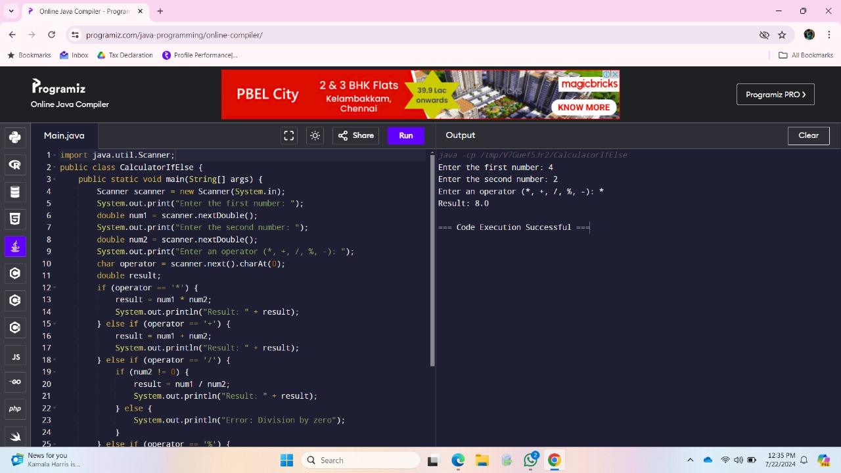

**4.** **Write a Java program to do the following that determines your weight on another planet. The program should ask for the user's weight on Earth, then present a menu of the other planets in our solar system. The user should choose one of the planets from the menu. The program should display the phrase like the following: “Your weight on Mars is 55 lbs.” Use the following conversion factors**

*import java.util.Scanner;*

*public class WeightOnPlanet {*

*public static void main(String[] args) {*

*Scanner scanner = new Scanner(System.in);*

*System.out.print("Enter your weight on Earth (lbs): ");*

*double earthWeight = scanner.nextDouble();*

*System.out.println("Select a planet to find your weight on that planet:");*

*System.out.println("1. Mercury");*

*System.out.println("2. Venus");*

*System.out.println("3. Mars");*

*System.out.println("4. Jupiter");*

*System.out.println("5. Saturn");*

*System.out.println("6. Uranus");*

*System.out.println("7. Neptune");*

*System.out.print("Enter the number of your choice: ");*

*int choice = scanner.nextInt();*

*double conversionFactor = 0;*

*String planetName = "";*

*switch (choice) {*

*case 1:*

*conversionFactor = 0.38;*

*planetName = "Mercury";*

*break;*

*case 2:*

*conversionFactor = 0.91;*

*planetName = "Venus";*

*break;*

*case 3:*

*conversionFactor = 0.38;*

*planetName = "Mars";*

*break;*

*case 4:*

*conversionFactor = 2.36;*

*planetName = "Jupiter";*

*break;*

*case 5:*

*conversionFactor = 0.92;*

*planetName = "Saturn";*

*break;*

*case 6:*

*conversionFactor = 0.89;*

*planetName = "Uranus";*

*break;*

*case 7:*

*conversionFactor = 1.13;*

*planetName = "Neptune";*

*break;*

*default:*

*System.out.println("Invalid choice. Please run the program again and select a valid option.");*

*scanner.close();*

*return;*

*}*

*double planetWeight = earthWeight * conversionFactor;*

*System.out.printf("Your weight on %s is %.2f lbs.%n", planetName, planetWeight);*

*scanner.close();*

*}*

*}*

**5. Write a Java program that will decide if a student gets into Mountville University. Students must have one of the following criteria: • been a valedictorian or salutatorian of a school of 1400 or more • had a gpa of 4.0 or better and a SAT score of 1100 or more • had a gpa of 3.5 or better and an SAT score of 1300 or more • had a gpa of 3.0 or better and an SAT score of 1500 or more**

.

import java.util.Scanner;

public class MountvilleUniversityAdmission {

public static void main(String[] args) {

Scanner scanner = new Scanner(System.in);

System.out.println("Enter student information:");

System.out.print("Is the student a valedictorian or salutatorian (yes/no)? ");

String valSalStatus = scanner.next();

int schoolSize = 0;

if (valSalStatus.equalsIgnoreCase("yes")) {

System.out.print("Enter the size of the school: ");

schoolSize = scanner.nextInt();

}

System.out.print("Enter the student's GPA: ");

double gpa = scanner.nextDouble();

System.out.print("Enter the student's SAT score: ");

int satScore = scanner.nextInt();

boolean admitted = false;

if (valSalStatus.equalsIgnoreCase("yes") && schoolSize >= 1400) {

admitted = true;

} else if (gpa >= 4.0 && satScore >= 1100) {

admitted = true;

} else if (gpa >= 3.5 && satScore >= 1300) {

admitted = true;

} else if (gpa >= 3.0 && satScore >= 1500) {

admitted = true;

}

// Output the result

if (admitted) {

System.out.println("The student is admitted to Mountville University.");

} else {

System.out.println("The student is not admitted to Mountville University.");

}

scanner.close();

}

}